October 14, 2025

Dr. Jenahvive Morgan
College of Engineering
Michigan State University
219 Wilson Road
East Lansing, MI 48825

Dear Dr. Morgan,
Attached is a copy of Section 10, Team 4’s Project #1 Report for EGR 100.
This report describes the design process for creating an educational mobile game called ‘Sum Drop’ to enhance students’ arithmetic skills. The initial design of the app is described, as well as the methods used to structure its two modes of operation: addition/subtraction and multiplication. The results of initial user testing were reported and analyzed.
Using the MIT App Inventor, the initial design was developed as a simple and engaging mobile game. In the addition/subtraction mode, users catch falling positive and negative numbers in a bucket and calculate the algebraic sum. After 60 seconds, the user inputs their calculated sum to determine whether they won or lost. The multiplication mode follows a similar structure, requiring the user to find the product of falling integers.
I hope this report meets your requirements, and any questions will gladly be addressed by email.
Sincerely,
Dhruv Garg, Noah Gordan, Joseph Holmes, Jeremiah Ramirez
INTRODUCTION

Traditional methods for teaching arithmetic skills involve back-to-basics education. Therefore, students struggle to maintain accuracy and speed in basic arithmetic operations. Speed in basic mathematical calculations is crucial for success in topics such as Calculus, Artificial Intelligence, Data Science, Physics, Engineering, Economics, and Financial Modelling.

Gamification refers to the integration of game-like elements, such as scoring, levels, rewards, and competition, into non-game or educational contexts to enhance user engagement. Research suggests that gamification can significantly improve motivation and learning outcomes [1],[2].

The core problem being solved is the decline in engagement with simple mathematical practice. The proposed solution is an interactive mobile application designed to make learning addition, subtraction, and multiplication an enjoyable experience. The primary objective was to create a fully functional game using MIT App Inventor that challenges users in a timed and interactive environment. In this way, students can learn to calculate sums faster and become more accurate in their calculations.

METHODS

The mobile application was designed and developed using the MIT App Inventor, a visual block-based programming environment. The screen architecture includes the use of multiple screens to perform different actions.

The app starts with a main screen displaying the name of the game, ‘Sum Drop’, and prompting the user to start the game. Figure 1 illustrates the interface of the main screen.

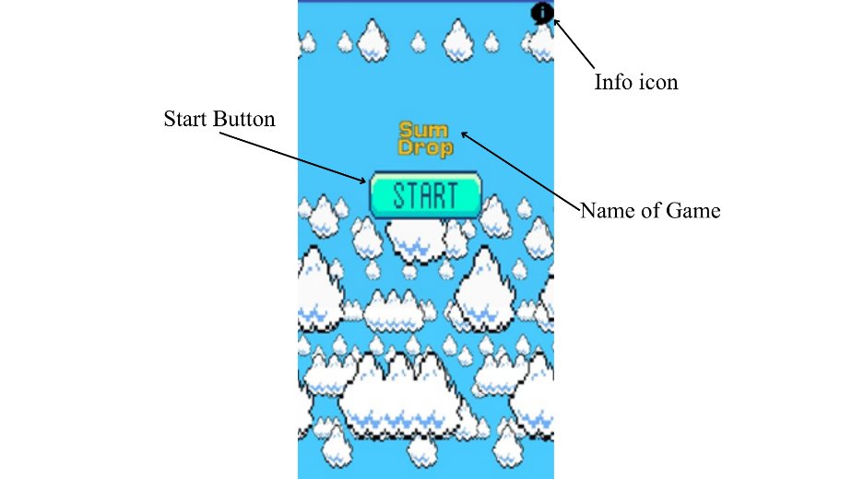

Figure 1: The start screen of the mobile application with the game title, start button, and info button.

The info icon in Figure 1 is a button that opens a new screen to display the game instructions. These instructions allow the user to understand the rules of the game. The start button in Figure 1 leads to the menu screen, which consists of two primary buttons named “Addition Mode” and “Multiplication Mode.” The two buttons are responsible for leading the user to the correct game experience. Figure 2 shows the screen interface and program blocks for this screen.
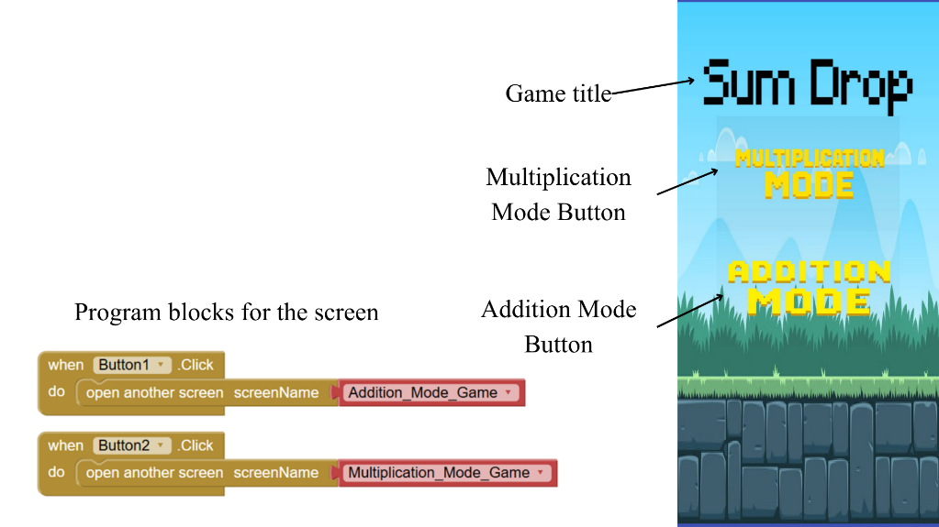

Figure 2: Code snippet & screen design for the menu screen with functions for the two primary buttons.

In Figure 2, the first code block corresponds to the “Addition mode” button, which takes the user to the Addition/Subtraction game. The second code block corresponds to the “Multiplication Mode,” which takes the user to the multiplication version of the game.

When the user clicks the “Addition Mode” button, the app goes to the Addition_Mode_Game screen. Figure 3 illustrates the working screen design at an instant.

Figure 3: Addition_Mode_Game screen.

In Figure 3, random positive and negative numbers fall from the top of the screen. The user horizontally slides the bucket using the finger to ‘catch’ the numbers in the bucket. Simultaneously, the user must calculate the sum of the collected numbers. This sum may also involve adding negative numbers, which intuitively requires subtraction skills. The game runs for 60 seconds and then terminates, leading the user to the calculation screen.

When the “Multiplication mode” button in Figure 2 is clicked by the user, the app goes to the Multiplication_Game_Mode screen. This game mode involves falling integers, except for zero. The numbers fall into the user’s sliding bucket, and the user must simultaneously multiply the current number by the number that falls into the bucket. After the game runs for a complete 60 seconds, the user is taken to the calculation screen.

The calculation screen is the most critical screen for the user and the application, as it involves two steps. First, the user must enter the correct sum (addition or multiplication). Second, the program must be able to recognize the sum and compare it with the correct value to determine whether the game state is winning or losing. Figure 4 is a design of the calculation screen.


Figure 4: Calculation Screen with title, input box, and submit button.

Figure 4 is the calculation screen that consists of a title prompting the user to enter the calculated sum in the provided textbox. Afterwards, the submit button will inform the program to verify the accuracy of the entered sum and transition to one of the two end screens. Figure 5 shows the game-over screen.


Figure 5: Lose End Screen with title (Game Over) and restart button.
The game-over screen in Figure 5 is displayed when the user provides an incorrect evaluation of the sum. The restart button on the screen allows users to play the game again. The app also displays a message using the MIT App Inventor’s notifier element to state the correct sum.

The win screen becomes the end screen for the game when the user correctly evaluates the sum. This screen consists of a title stating, ‘You Win’ and the text ‘Congratulations’ to encourage the user for the achievement. The screen also consists of a restart button to allow the user to replay the game. Figure 6 shows the design of the win screen.

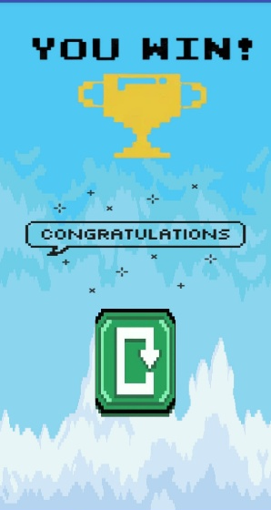
Figure 6: Win End Screen with title (You Win), Congratulations text, and Restart Button.

To assess the design’s effectiveness, a data collection was conducted via a user survey. 10 random participants were asked to use the application and subsequently answer a short survey questionnaire. The survey was designed to gather quantitative data on three metrics: the estimated number of times the user would use this application each week, the duration in minutes of their single session, and their likelihood of using the app in the future, rated on a scale from 1 (Not Likely) to 5 (Very Likely). This data was recorded, and a comprehensive analysis was created.

RESULTS

The data gathered from the 10-user survey were compiled and analyzed to evaluate the initial user engagement with the initial design of the game. A summary of the complete dataset is presented in Table 1.

Table 1: Summary of 10-user survey data with calculated Mean and Standard Deviation.

The survey results indicated the following key findings. For the estimated weekly usage, the mean was calculated to be 4.2 times per week, with a standard deviation of 1.54. This suggests consistent and frequent user engagement, implying that the app encourages users for regular use. For the usage time per week, the mean was 20 minutes, with a standard deviation of 8.37. This suggests that the 60-second game loop session is sufficiently engaging to encourage users to play multiple rounds in a single week.

For the likelihood of using the app in the future, on a scale of 1 (Not Likely) to 5 (Very Likely), the mean was calculated to be 4 (Likely), with a standard deviation of 0.77. This suggests that the game interface and user experience were both good standards for higher app engagement among users.

The results show low variability in session count, indicating stable usage habits. Time variability reflects different playing styles. Given that each game loop is only 60 seconds, this suggests users playing multiple rounds per session, indicating strong user engagement.

A scatter plot was generated to visualize the distribution of usage time per visit for all survey participants. This plot is shown in Figure 7 below.

Figure 7: Scatter plot to understand whether more frequent users also use the app for longer each week.

There are multiple instances of users who expect to use the app frequently but for shorter durations. Conversely, some users who expected to use the app less frequently reported higher usage durations. This suggests that app usage duration may be affected by personal preferences, goals, or the type of tasks performed. The data indicates a bimodal distribution where some respondents believe the task is relatively quick, while others estimate a longer duration. This may imply differing levels of familiarity or complexity among users.

CONCLUSION

The problem statement for this project was to address the lack of engaging mobile applications for arithmetic practice. Therefore, it is concluded that the app has demonstrated the completion of an initial design with potential for user satisfaction. The application was developed using the MIT App Inventor and incorporated the required features, such as image animation and in-program messaging.

Survey data collection was used to gather initial user feedback. The quality of the initial design, as assessed through a user survey, was promising. The quantitative results indicate that users would engage with the app multiple times a week for several minutes per week, suggesting that the core concept is effective. Future work will involve refining the app interface and incorporating user feedback to improve the app's overall appeal and functionality.

REFERENCES

[1] K. Squire, “Video Games in Education”, International Journal of Intelligent Simulations and Gaming, vol. 2, no. 1, pp. 49-62, 2003.
[2] S. B. Munavalli, “Impact of Gamification on Education”, International e-Journal of Library Science, vol. 11, no. 1, pp. 1017-1021, 2023

